INNOLOFT VENTURES | InnoTrack Daily Report | 20-Day Internship Program

DAILY INTERNSHIP REPORT
Submit this report on InnoTrack by 5:00 PM every day
SECTION 1 — STUDENT INFORMATION

Student Name | Nareddy.Shanmukha NihalReddy | VTU ID | 28683
Branch / Dept. | CSE(AI&DS) | Internship Day No. | 4
Date | 04/06/2026 | Track (1 / 2 / 3 / 4) | 1
Project Title | Customer Churn Prediction System - E-commerce | Mentor Name | JAYASRI

SECTION 2 — WHAT DID YOU LEARN TODAY?

Topic / Concept Learned
Learned data visualization using Matplotlib, including creating bar charts, scatter plots, histograms, and line charts to analyze customer churn data.
Learned the fundamentals of Machine Learning, including train-test splitting, Logistic Regression model building, feature comparison, model evaluation, and saving/loading models using Pickle.
Gained hands-on experience in applying machine learning concepts to a real-world Customer Churn Prediction project, including project planning, feature selection, and GitHub documentation using README files.

SECTION 3 — WHAT DID YOU BUILD TODAY?

Code / Output / Feature Built
Charts in One File:
https://github.com/NSNihalreddy/VELTECH-SUMMER-INTERNSHIP-/blob/main/Innolift%20Ventures/Track%201/DAY%204/TASK%201.py
OUTPUT:
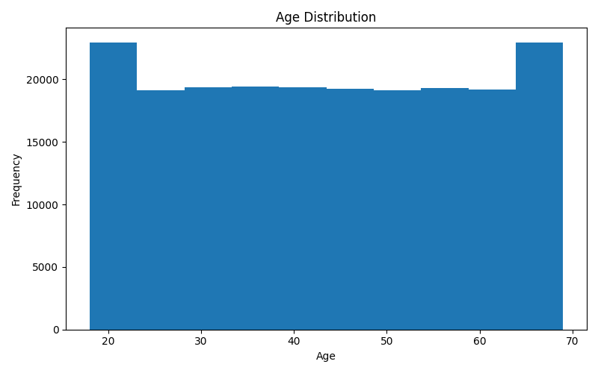

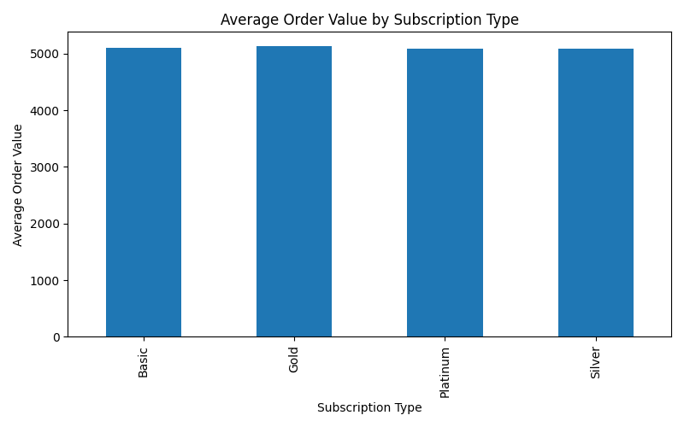

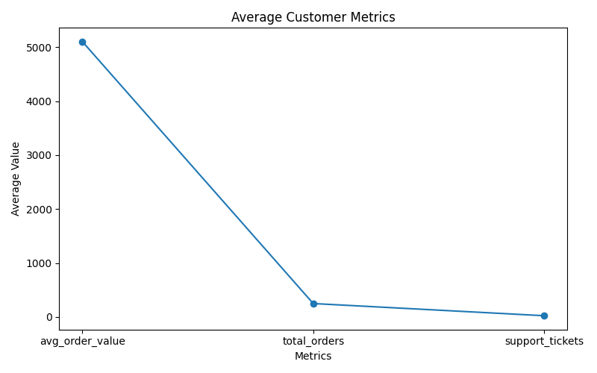
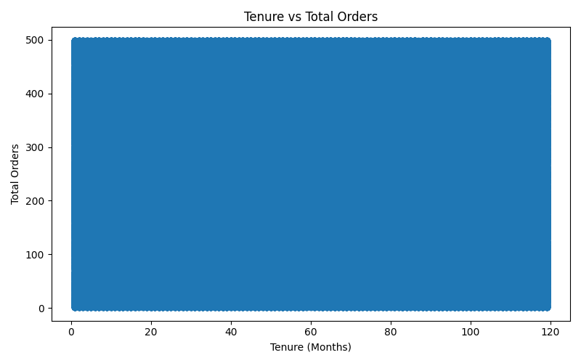

FEATURE BUILT:
Created four different visualizations (Bar Chart, Scatter Plot, Histogram, and Line Chart) using the customer churn dataset.
Generated and saved chart images as PNG files for data analysis and reporting.
Custom Styled Chart:
https://github.com/NSNihalreddy/VELTECH-SUMMER-INTERNSHIP-/blob/main/Innolift%20Ventures/Track%201/DAY%204/TASK%202.py
OUTPUT:
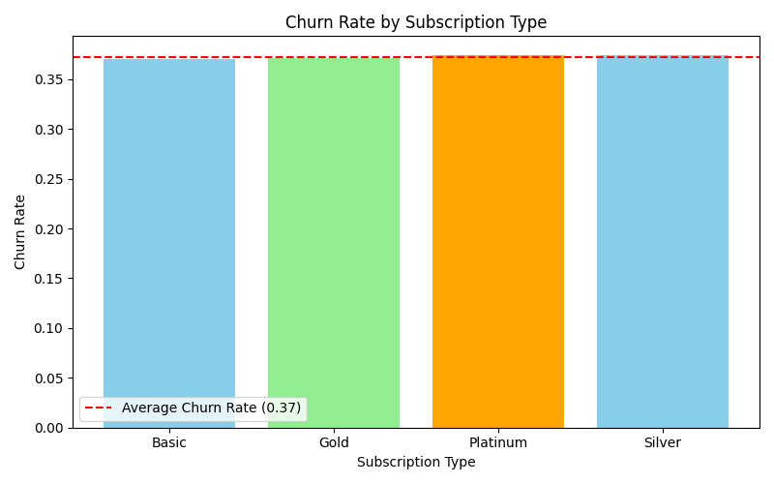

FEATURE BUILT:
Developed a customized bar chart showing churn rate by subscription type.
Added chart title, axis labels, custom colors, legend, and average churn rate reference line.
Train-Test Split Explorer:
https://github.com/NSNihalreddy/VELTECH-SUMMER-INTERNSHIP-/blob/main/Innolift%20Ventures/Track%201/DAY%204/TASK%203.py
OUTPUT:
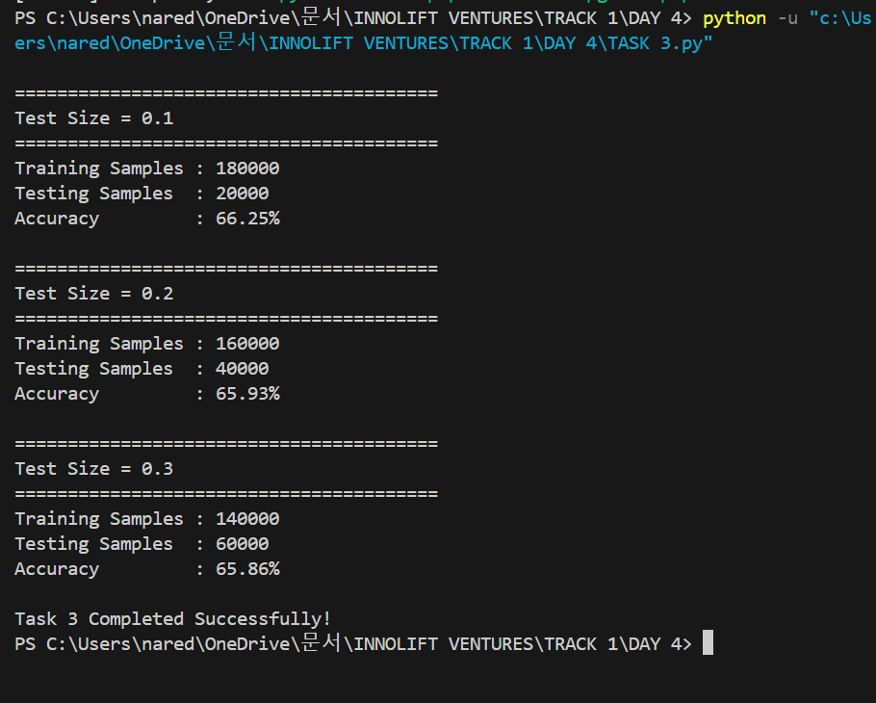
FEATURE BUILT:
Implemented multiple train-test split configurations (10%, 20%, and 30% test data).
Compared training/testing sample sizes and model accuracy across different splits.
Customer Churn Prediction Model:
https://github.com/NSNihalreddy/VELTECH-SUMMER-INTERNSHIP-/blob/main/Innolift%20Ventures/Track%201/DAY%204/TASK%204.py
OUTPUT:
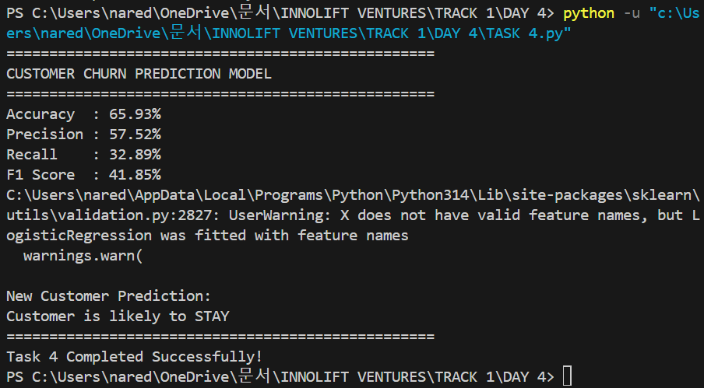
FEATURE BUILT:
Built a Logistic Regression model using multiple customer features.
Evaluated model performance using Accuracy, Precision, Recall, and F1-Score metrics.
Feature Comparison Analysis:
https://github.com/NSNihalreddy/VELTECH-SUMMER-INTERNSHIP-/blob/main/Innolift%20Ventures/Track%201/DAY%204/TASK%205.py
OUTPUT:
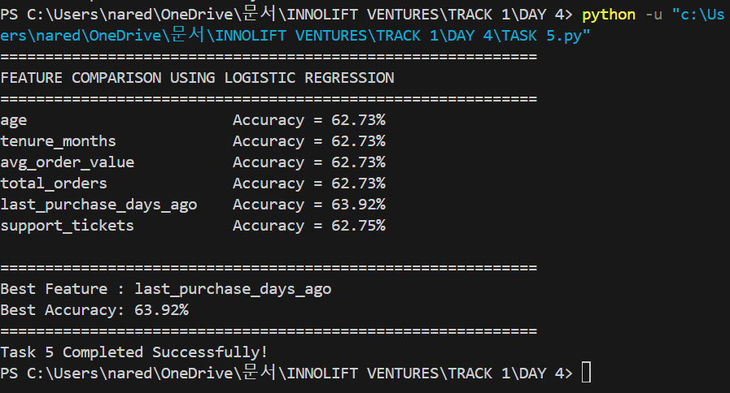

FEATURE BUILT:
Trained separate models using individual features to measure their predictive power.
Identified the most influential feature for customer churn prediction.
Predict vs Actual Visualization:
https://github.com/NSNihalreddy/VELTECH-SUMMER-INTERNSHIP-/blob/main/Innolift%20Ventures/Track%201/DAY%204/TASK%206.py
OUTPUT:
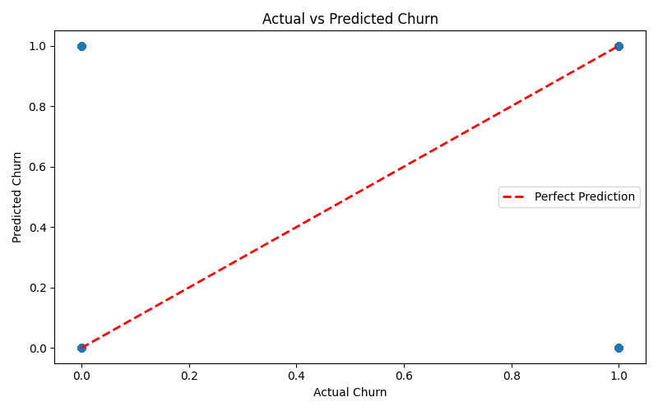

FEATURE BUILT:
Created a scatter plot comparing actual churn values with model predictions.
Added a reference line to visually assess prediction accuracy.
Model Saving and Reuse:
https://github.com/NSNihalreddy/VELTECH-SUMMER-INTERNSHIP-/blob/main/Innolift%20Ventures/Track%201/DAY%204/TASK%207%20train%20model.py

https://github.com/NSNihalreddy/VELTECH-SUMMER-INTERNSHIP-/blob/main/Innolift%20Ventures/Track%201/DAY%204/TASK%20%207%20Predicted%20model.py

OUTPUT:
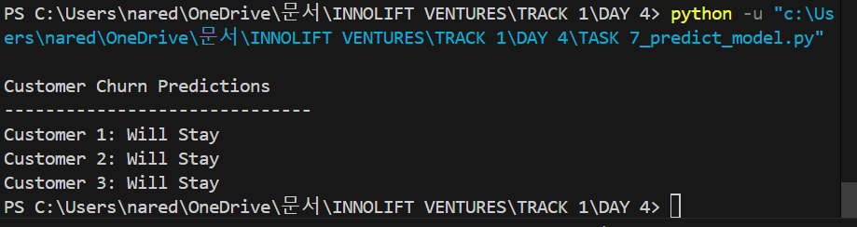
FEATURE BUILT:
Saved the trained churn prediction model using Pickle.
Loaded the saved model and generated predictions for new customer records.
Mini Project Planning:
https://github.com/NSNihalreddy/VELTECH-SUMMER-INTERNSHIP-/blob/main/Innolift%20Ventures/Track%201/DAY%204/TASK_8_README.md

FEATURE BUILT:
Defined project scope, dataset details, features, target variable, business objective, and expected outcomes.
Prepared professional project documentation using a GitHub README file.

SECTION 4 — PROBLEMS FACED & HOW YOU SOLVED THEM

Error / Problem
Encountered missing library errors such as matplotlib and scikit-learn while running visualization and machine learning tasks.
Faced challenges selecting appropriate features, target variables, and adapting the Day 4 exercises to the Customer Churn dataset.
How I Fixed I (Describe your solution or what help you took)
Installed the required packages using pip and verified the Python environment before executing the programs.
Analyzed the dataset structure, identified relevant input features and target columns, and modified the tasks to fit the churn prediction project requirements.

SECTION 5 — PLAN FOR TOMORROW

What will you do tomorrow?
Begin the assigned individual project by performing detailed data exploration, data cleaning, and identifying important features for model development.
Improve the churn prediction model through feature engineering, model tuning, performance evaluation, and prepare project documentation with updated GitHub repository submissions.

SECTION 6 — LINKS & ATTACHMENTS

GitHub Repo / Commit Link | https://github.com/NSNihalreddy/VELTECH-SUMMER-INTERNSHIP-/tree/main/Innolift%20Ventures/Track%201/DAY%204
Model Result / Colab Link | Successfully trained a Logistic Regression model to predict customer churn using customer demographics, purchase history, and engagement metrics.  Evaluated the model using Accuracy, Precision, Recall, and F1-Score, and generated predictions for new customers while identifying the most impactful features affecting churn.
Deployed App Link (if any) | NA
Additional Notes | Successfully completed all Day 4 tasks using the Customer Churn Prediction dataset and gained practical experience in data visualization and machine learning workflows.  Learned how to save trained models using Pickle, create professional project documentation with README files, and organize project files for GitHub submission.

SECTION 7 — SELF RATING FOR TODAY

Area | 1 | 2 | 3 | 4 | 5
Understanding of today's concept | ☐ 1 | ☐ 2 | ☐ 3 | ☐ 4 | ☑ 5
Hands-on coding confidence | ☐ 1 | ☐ 2 | ☐ 3 | ☐ 4 | ☑ 5
Progress on my project | ☐ 1 | ☐ 2 | ☐ 3 | ☐ 4 | ☑ 5
Overall satisfaction with today | ☐ 1 | ☐ 2 | ☐ 3 | ☐ 4 | ☑ 5

